**DEVELOPMENT OF AN E-LIBRARY SYSTEM FOR ONLINE MONITORING USING GOOGLE ANALYTIC**

**BY**

**NWACHUKWU DAVID – F/HD/15/3210137**

**FRIDAY MERCY – F/HD/15/3210033**

**OYESANYA MUTIAT – F/HD/15/32100138**

**MAFO ABBEY ABIOLA – F/HD/15/3210156**

**A PROJECT SUBMITTED IN PARTIAL FULFILMENT OF THE REQUIREMENT FOR THE AWAD OF HIGHER NATIONAL DIPLOMA CERTIFICATE IN COMPUTER SCIENCE**

**TO**

**DEPARTMENT OF COMPUTER TECHNOLOGY SCHOOL OF TECHNOLOGY**

**YABA COLLEGE OF TECHNOLOGY, YABA, LAGOS.**

**SEPTEMBER, 2017**

**TABLE OF CONTENT**

Abstract 3

**Chapter One: Introduction 4**

* 1. Background of the study 4
  2. Statement of problem 5
  3. Aims/Objectives of the study 5 - 6
  4. Methodology 6
  5. Significance of the study 7
  6. Scope of the study 7
  7. Motivation of Study 7

**Chapter Two: Literature review 8**

2.1 E-library(Electronic Library) 8 - 9

2.1.1 Google Analytics 9

2.2 Related Works 10 - 11

2.3 Project Gap 11 - 12

**Chapter Three: System Analysis and Methodology 13**

3.1 Description of the System 13

3.2 Proposed Model 13

3.3 System Design 14

3.4 Research Instrument/Data Gathering 15

3.5 Operation of E-library using Google Analytics 15

3.5 Hardware and Software requirements 16

3.6 Expected contribution to Knowledge 17

3.7 System Flow Chart 18

3.7 Conclusion 19

**REFRENCES 20 - 21**

**ABSTRACT**

*Electronic libraries are the most complex form of information systems that supports digital document preservation, distributed database management, hypertext, filtering, information retrieval and selective dissemination of information. The study examines the concept of e-library, the technology that has enabled its emergence and aims at building a system that checks the usefulness of the e-library contents to the readers. This will help to create a web based library that keeps track of traffic in the site, web pages visited, the number of page views, decreased bounce rate, average time on site, page per visit, percentage of new visits and give feedback to system administrators of satisfactory report of each user. The data collected will be processed by Google Analytics which is a web analytic tool. The aim of this study is to develop an e-library system that monitors the behaviour of online readers and capture user’s feedback to help future e-library systems improve the quality of information and the e-library system based on users’ feedback.*

***Keywords****:* E-library, E-library resources, Digital Library, Web Analytics, Google Analytics.

**CHAPTER 1**

**INTRODUCTION**

**1.1 Background Study**

An electronic library is a special library with a collection of digital resources that can include text, 3D visual material, audio material and video material stored as electronic media formats, along with means for organizing, storing, and retrieving the files and media contents in the library collection. Electronic libraries can vary immensely in size and scope, and can be maintained by individuals, organizations, or affiliated with established physical library buildings or with academic institutions.

Library automation started in the 1960s in the USA. Since then the trend of library automation has been spreading all over the world. Nowadays libraries are continuously increasing in number, and most are being automated. This automation is actually a combination of hardware and software, both being necessary for any automated system. In the field of libraries, software has become more important than hardware. Hundreds of library software packages have been developed and run successfully in advanced countries and there are many directories and other tools available to help librarians in the selection of suitable software for their libraries (Fadhil 2014).

The perception of users towards e-library resources, facilities and services found that users are highly satisfied with it. Users are highly aware and satisfied about the e-library resources such as e-journals, e-books, websites, online databases and stored-data on audio compact disk, video compact disk, and compact disk – read only memory (Ekere et al. 2016). The application Web 2.0 represents an emerging suite of applications that hold immense potential in enriching communication, enabling collaboration and fostering innovation. However, little work has been done previously to research Web 2.0 applications in library websites (Chua & Goh, 2010).

University libraries have invested a large amount of resources into digitizing information for the Web, yet scholars and practitioners question the value of this investment due to a lack of use of university library website resources (ULWR) (Yong-Mi kim 2010). The significant effect of system quality on perceived usefulness suggests that by improving the fit between e-library systems and user information needs, we cannot only generate positive perceptions about the usefulness of e-libraries but also about the ease of their use (Jeong, 2011). Nigerian Libraries can leverage on social networking and social media skills to provide dynamic library services in the face of decreasing economic problems (Ezeani, 2012). Hence, this project proposes an effective means of monitoring the e-library (using Google Analytics) to check the usefulness of the resources to readers based on their feedback.

* 1. **Statement of Problem**

Most e-library system have been facing the problem of poor services, outdated collection of reading materials, too many clicks per page which increases the bounce rate from one page to another, no monitoring system to track users behaviour on the e-library system and to capture users feedback.

Monitoring of Electronic-library also face challenge regarding policy, legal consideration such as copyright, environmental factors, established mechanisms for deposit, information retrieval and access, preservation, human resources, financial implications and trust. Hence this study aims at building a monitoring system that tracks users behaviour, provides users with updated information and checks the usefulness of e-library resources based on user’s feedback.

**1.3 Aim and Objectives**

The aim of this study is to develop an e-library system that monitors the behaviour of online readers and capture user’s feedback.

The specific objectives are to:

* Build a system that checks the usefulness of the e-library contents to the readers and automatically checks the number of times users log in to the system, the duration spent on the system and the satisfactory report of each user
* Analyse the data using a data mining software, and provide adequate information of how users feel about what they read.
* Encourage co-operative efforts which influence the considerable investments in research resources, computing and communications network.

**1.4 Methodology**

To achieve the stated objectives, past literatures were reviewed for both traditional and digital library systems. Past related project work was reviewed. Also, interview was conducted among some online readers and higher institutions using an e-library platform. The proposed project is a web based system which enables access to the system from various locations. Users interface are sketched and this design will be done using Google Analytics and web analytics. This implementation involves creating a Google Analytics account, setting up a profile for a website to be tracked, and then embedding the automatically generated tracking code into the hypertext mark-up language (HTML) code of every single web page on a website, copying, pasting and adding the script to the website. Google Analytics can be functional in a matter of minutes and the e-library can start earning the benefits of knowing how visitors find and interact with its website.

**1.5 Significance of the Study**

This system will be of great benefit to scholars, librarians, institutions and mostly the educational sector by monitoring users on e-library platforms. It will help to disseminate accurate information to all users and let authors to know the mind of readers and their opinion. It also creates avenue for students to read and research at the comfort of their homes (or wherever they have access to internet) at any time without stress, access to the e-library 24/7, strengthen communication and collaboration between and among educational institution.

1.6 **Scope of Study**

The scope of the study is to develop an e-library system hosted on the web and integrated with Google Analytics to monitor user’s behaviour and analyse captured data. The monitoring system can be integrated with existing e-library platforms such as college library, academic libraries.

**1.7 Motivation for the Study**

The Development of educational system in countries today, are now adopting the use of e-library due to its effectiveness and easy access to resources online. Monitoring system, getting users feedback and a platform that makes users to rate e-book use should be given more attention in order to improve the e-library system. Although e-library offers a lot of opportunities for the expansion of education and learning but the major challenge in e-library today is the issue of not monitoring, no feedback, and problem of Information organization.

**CHAPTER TWO**

**2.0 LITERATURE REVIEW**

**2.1 E-library**

An electronic library can be defined as a collection of library resources in electronic/digital format at various locations, which can be accessed and used with great ease using computer information technologies for the purpose of teaching, studying, research, learning, leisure, and decision-making (Kehinde, 2017). Electronic library is the collection of large and diverse repositories of digital objects and information which can be accessed by a large number of geographically distributed users (Thillar, 2016)**.** A digital library is a collection of information that is stored and accessed electronically. The information stored in the library should have a topic common to all the data. For example, a digital library can be designed for computer graphics, operating systems, or networks. These separate libraries can be combined under one common interface that deals with computers but it is essential that the information contained within each library remain separate (Balasubramani, 2015). A full service electronic library must not only fulfill all essential services provided by traditional libraries but also make good use of the advantages of digital technology. An electronic library is a type of service that allows users, without actually entering into the library, to read library books and conduct research at home, in office, or at school, using the Internet. This is a new library service that applies rapidly advancing data processing technology and networking technology and it is expected to become a highly convenient, effective and efficient mode of service. Naga Raja Rao (2013) indicated in his communication that present new technologies are being used in library and information science and is the main reason in changing environment of libraries, but staff needed to manage the new digital libraries is to be flexible in adapting and adopting new skills and levels of awareness. Librarians have to adapt different skills to cope up with new technologies. It is often said that digital information is transforming the way we learn, the way we communicate and even the way we think. It is also changing the ways libraries and archives not only work, but more fundamentally the work that they do (Kanndppanavar, Rajanikanta, & Tandur, 2010).

Many articles regarding the assessment of library websites consist of surveys and the use of Google Analytics to determine the top pages of content. Understanding user needs and user behavior on library websites is crucial to designing a successful library website. According to a team at Texas Tech University, “properly assessing the needs and behavior of academic library patrons is essential to the design process of library Web sites” (Barba et al. 2013).

Turner (2010) describes library website key performance indicators as based on library website goals, user behavior, and user actions or tasks. In addition, Turner also establishes that Google Analytics can take micro measurements such as the number of times a specific resource is clicked on.

**2.1.1 Google Analytics**

**Google Analytics** is a widely used, free web analytics tool that collects, analyses, and reports website traffic data. It is also a powerful tool that offers a wide range of reports and features not found in other web analytics tools on the market. More importantly, it is fairly easy to use in the sense that, you do not have to be an expert in web programming or worry about installing the software on a web server in order to implement it on the website. Its price tag alone makes it a very desirable option for libraries to adopt. E-library can be monitored using other measures but the most robust is Google Analytics. The basic Google Analytics implementation involves creating a Google Analytics account, setting up a profile for a website to be tracked, and then embedding the automatically generated tracking code into the hypertext mark-up language (HTML) code of every single web page on a website. Google Analytics can be functional in a matter of minutes after adding script to website, allowing libraries to gain the benefits of knowing how visitors find and interact with its website. (Clifton, 2012)

**2.2 Related work**

Demand for electronic information increases day by day, it has become more convenient to use a library through the invention of Digital and Web Based Libraries specialised on various information fields of interest which is hosted on the web or could be an application on your smart devices (Mobiles phones, Tablets, Computers, and Laptops). Khan & Quatab (2016), investigated the factors that influenced the adoption of Digital Library among research students. The findings revealed that, interface characteristics influence cognitive response which predicts student’s intention of using digital library, whereas the navigation, individual differences and system characteristics significantly affected the ease of use. Usefulness is directly affected by system characteristics and system quality. Finally, it was discovered that usefulness has highest effects on digital library usage intention.

Starr (2009). The Nevada State Library and Archives proposed the Nevada Statewide Digital Planning, Survey & Report Library whereby the collection of the state work and activities can be connected together on a digitalized platform and interrelate different activities together using Google tag for the purpose of monitoring system and user activities per time and it was found that the top materials digitized were flat works on paper/photographic prints, maps, architectural drawings, posters, and film materials. They were also acquiring born digital resources including still images, simple text encoded text (blogs, websites, PDF documents), digital audio and digital video.

Bala (2017), proposed a web-based library service quality and user loyalty in the context of a developing country which aims to empirically investigate the relationship between perceived web-based service quality and three other latent constructs, namely, user satisfaction, service value and user loyalty. A quantitative survey design was used to collect the data. Structural equation modelling was used to determine the influence of web-based service quality on the three latent constructs. The respondents were students, academic staff and non-academic staff from two federal universities in the North-western zone of Nigeria. The findings of the path analysis indicate that perceived web-based service quality and service value exhibit no statistically significant direct influence on user loyalty.

Xianjin (2015) worked on Flow experience with respect to Mobile Library and try to compare perception of users with mobile libraries and web digital libraries with respect to flow experience. Where flow experience is defined as best experience about an activity that can be done by comparing perceived skills and perceived challenges. Study reveals that more users experienced flow in using web digital libraries than mobile libraries.

Cleveland (2015) in his project combined three methods of building digital collections: digitization, acquisition of original works and access to external materials. Providing access to external materials through subscriptions to e-resources (e-books, e-journals) this was one of the fastest way offering digital content where leased electronic resources were made available without being acquired (Fenner, 2016). Most importantly, the system was linked to a whole web of other content, locally and globally via the Internet. In is material he concluded that Today many libraries were going digital by subscribing to online databases and through digitization program of the library‟s collection even though it was a common place that not all existing collections would be digitized. Establishing hypertexts linkages to related websites/homepages was also another option of giving access to external materials.

Hess (2012) A librarians at DePaul University combined different Google Analytics dashboards into one single dashboard. This methodology allows data reviewers to see multiple domains in a single dashboard and to view user flow among the trackable domains for a library. Hess and his team applied code that forced Google Analytics to view different domains as being the same. This enabled them to track use data fluidly in one location via page views. This forcing of Google Analytics resulted in all web domains being able to be viewed as one domain. The subsequent data dashboard is referred to as “über analytics.” For example, a single dashboard would cover a specific domain, such as library.boisestate.edu, but the über dashboard combines: library.boisestate.edu, guides.boisestate.edu, catalog.boisestate.edu, and more.

**2.3 Project Gap**

Previous literature suggests several ways of using Google Analytics to improve library’s main portal; however, little research has investigated how to track user pathways on a library website using Google Analytics. Existing research regarding key performance indicators in Google Analytics are not analysed through the lens of user experience, nor is there research on how the use of Google Analytics impacts access to library resources. Instead, the primary articles on using key performance indicators in Google Analytics are oriented towards e-commerce sites to track transaction time and clicks to purchases to serve commercial entities (Fagan 2014).

This review of the literature shows that event tracking has not been thoroughly researched in E-libraries. Thus, the aims of this research project is to design a web based library system that gives room for event tracking to increase retention, decrease bounce rate, and measure actual drop-offs from the library website. This will result in a web site with a 10 percent or less bounce rate, and decreased the number of clicks required for users accessing the library’s content.

**CHAPTER 3**

**SYSTEM ANALYSIS AND DESIGN**

**3.1 Description of the System**

The system provides a web based library that grants user access to an online platform, and intends to investigate the effectiveness of high level automation library system by monitoring user’s satisfaction and behaviour using Google Analytics. Google Analytics shows high level dashboard data type for casual users and in-depth data for report set. It includes Google website optimizer rebranded as Google analytics content experiments. The newer version of Google Analytics tracking code is known as the asynchronous tracking code, which Google claims is significantly more sensitive and accurate, and is able to track even very short activities on the website. The Web based library system’s main idea is to implement a network based application for uploading, downloading required information for research and request for books or materials through online application. In this case we use Google analytics to capture user’s data. In addition to collecting data for navigation to this content through the website, our acquisitions staff are using this data to evaluate which databases and digital content need to be kept.

**3.2 Proposed Model**

User

Admin

External system

**Figure 3.1: Use case for the E-Library System**

The above diagram depicted the activities that can be perform by the users, admin and third party applications when using the system in a simple flowchat.

The Admin have the access to almost all the functionality of the system which includes;

* Login
* Browse information
* Create New Information
* My Information
* Contact Us
* About us.
* Manage Users
* Logout

The User has the access to almost all the functionality of the system which includes;

* Login
* Register
* Browse information
* Create New Information
* My Information
* Contact Us
* About us.
* Logout

The Third Party System has the access to almost all the functionality of the system which includes;

* Browse information
* Create New Information
* Manage Users

E-library system represents the richness and wealth of information which provides the unsophisticated users with flexible access to rich and complicated information. The key components of digital library system are represented in the following chart.



**Figure 3.2: The Electronic Library System Architecture**

**Major system components of the System Architecture**

1. **User interfaces**

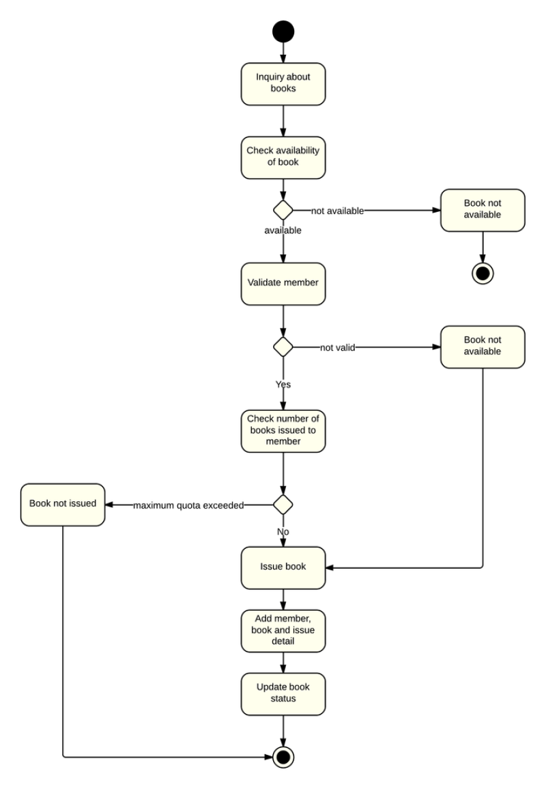This system provide unique interfaces for different users to interact with it: one for the users of the library, the other for the librarians and system administrators who manage the collections. Each user interface is in two parts. A standard Internet browser is used for the actual interactions with the user. This can be Microsoft's Internet Explorer or Mozilla Firefox. The browser connects to client services, which provide intermediary functions between the browser and the other parts of the system. The client services allow the user to decide where to search and what to retrieve; they interpret information structured as digital objects and convert among the protocols used by the various parts of the system.

1. **Repository**

Repositories store and manage digital objects and other information. A large electronic library may have many repositories of various types, including modern repositories, legacy databases, and Web servers. The interface to this repository is called the Xampp server. Features of Xampp are explicit recognition of rights and permissions that need to be satisfied before a client can access a digital object, support for a very general range of dissemination’s of digital objects, and an open architecture with well-defined interfaces. Xampp consist of MySQL, Apache and FireZilla for data redering and management

1. **Handle system**

Handles are general purpose identifiers that can be used to identify Internet resources, such as digital objects, over long periods of time and to manage materials stored in any repository or database. When used with the repository, the handle system receives as input a handle for a digital object and returns the identifier of the repository where the object is stored.

1. **Search system**

The search system is an embedded algorithm of regex implementation to craw user hint or query parameters.

**3.4 Research Instrument and Data Gathering**

Most information gathered were gotten from:

Using search engines to gather information, the web and using Google web Analytics which will be embedded into the e-library system to track slightest movement on the web pages.

**3.5 Operations of e-library Using Google Analytics**

Once user’s gain access the available resources (e-journals, e-books, websites, online databases, stored-data on audio and video compact disk(CD)) on the e-library, every single traffic created by the user is captured by Google Analytics. The time spent on each page and the satisfactory reports are all stored in a database, to be processed to derive statistical data on how this data helps the e-library platform, to improve it where necessary and to concentrate on more what platform of e-library is highly impactful to amplify cognition.

**3.6 Hardware and Software Requirement**

**Software**

To facilitate the use of web-based library system, some hardware and software should be adopted. The hardware and software are different for clients and server. For the operation system of the server, we choose windows 7 to manage the resources as it has user friendly interface. It can save cost for setting up a server. For the DBMS, MY SQL, PHP, CSS, HTML, JavaScript, Java MySQL or Apache web server will be used. Antivirus programs, NOD32 and firewalls are installed to ensure that the network will not be attached by the others. For the client side, a web browser should be used for clients to get access with the Internet. It allows users to access to web-based library system through the Internet and download designated file from the web server of the library. User can download anti-virus software to avoid illegal intrusion of personal information. They can also take an advantage of email client, Outlook express to get the email reminders from the library.

**Hardware**

A personal computer (PC) or a laptop, or a smart phone, Internet connection (MODEM). Minimum of 500MB RAM, 1.6GHz processor, 290 MB RAM, 600 MHz processor, and 180 MB for mobile phone. For the server, servers are set up to responds to the requests from clients including file server, print server. All the servers are incorporated with features suitable for storing and allocating huge amount of data on a network, and have fault-tolerant features that guarantee up time. Fault-tolerant means that even a part fails, the whole system can still operate. A Redundant Array of Inexpensive Disks (RAID) system would also be established. In a RAID system, it is a technology that employs the simultaneous use of two or more hard disk drives to achieve greater levels of performance, reliability, or larger data volume sizes. Also, a switch is needed to organize connected devices by allocating them into different Virtual LANs. At the same time, a router is also established to connect a LAN to the Internet. Network Interface Card (NIC) is needed to access to the Internet for the client side. Besides, basic components such as monitor, mouse and keyboard are required. Speakers are also preferable as there may be audio shown on the system.

**3.7 Expected Contribution to knowledge**

The expected contribution to knowledge is to develop an e-library system that provides the use of event tracking to increase retention, decrease bounce rate, and measure actual drop-offs. This will result in a web site with a 10 percent or less bounce rate, and decreased the number of clicks required for users accessing the library’s content.

**3.8 Conclusion**

Google Analytics is a great tool for constructing user centred websites. It offers a user-friendly interface and informational reports that allow for quick identification of problems. Event tracking with google analytics is a great way to manage a library website that connects users to hundreds of different vendors and to the library’s authoritative digital subscription content. The research reveal that events tracking of user pathways led to better decisions that improved the usability and functionality of the website.

**CHAPTER FOUR**

**IMPLEMENTATION AND RESULTS**

**4.1 System Requirements**

The system requirements are divided into two, which are hardware requirements and software requirement.

**4.1.1 Hardware Compatibility Requirements**

The following are the hardware specifications for the designed application:

* 787MHz or Higher Intel Premium Processor.
* 512Mb Memory (RAM) or Higher.
* VGA 800 x 600, 256 colour.
* Uninterrupted Power Supply
* Hard Disk Storage of 20GB Minimum.
* Smart Phones.
* Tablet Phone
  + 1. **Software Requirements**
* Windows XP, Vista 7 or 8.
* Web browser Google Chrome or other browser
* Reliable and licensed Antivirus software like Avast.
* Mysql database Server (Xampp or Wamp).

**4.2 Testing**

After implementation and sometimes during design, the application must be subjected to testing varieties which are:

* **Alfa Test:** This means self or in-house test of designed application for any syntax bugs or exceptions. It is done by the programmers during the design completion.
* **Beta Test:** This application will be released to the organization used as a case study for testing to see the suitability of usage.
* **Audit Test:** This test is likewise to be chosen in preference to beta test depending on the organization’s choice concordance with the programmer. It is achieved while the program designer establishes a scheduled training to the use of this web application.

**4.3 Data Input Interface**

**4.3.1. Login Page.**

The Login page accepts user information for logging the information require from the user so as to have access to other available resource on the application is the username and password. This is the first among the two pages permitted for and user without authorization or access can see when trying to access this page.

The page url will be vary from server to server but for the purpose of testing on local server the url is <http://localhost/elibraryGA/> , other description can be found on figure 4.1 below.

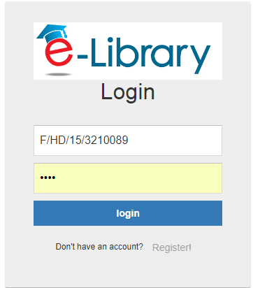

***Figure 4.1: Login Page***

**4.3.2 Register Page.**

The Register page accepts user information for signing up the information required from the user so as to have access to resources on the application. This is the first among the two pages permitted for and user without authorization or access can see when trying to access this page.

The page url will be vary from server to server but for the purpose of testing on local server the url is <http://localhost/elibraryGA/index/signup>, other description can be found on figure 4.2 below.

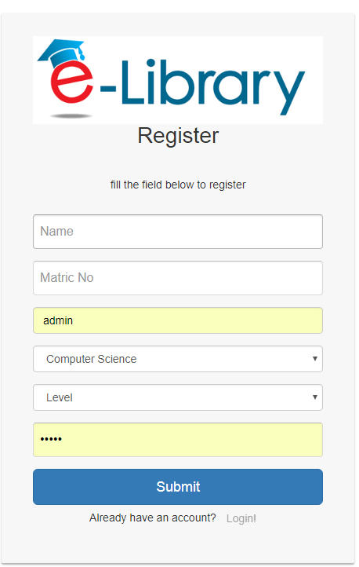

***Figure 4.2: Registration Page***

**4.3.3 Cloud Content Page.**

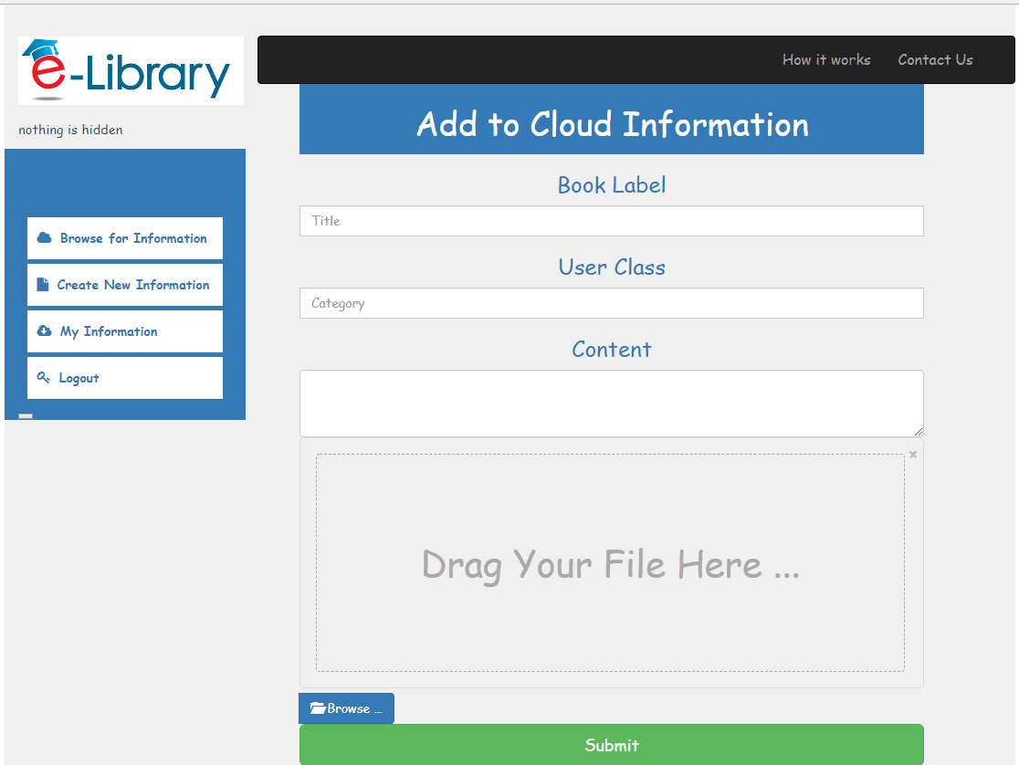

***Figure 4.3: Add information to the Cloud.***

The Add cloud information page accepts electronic document related information such as the material title, the class and the text content, the upload section allow user to attach electronic materials to the uploaded information and save

The page url will be vary from server to server but for the purpose of testing on local server the url is <http://localhost/elibraryGA/dashboard/save>, other description can be found on figure 4.3 above.

**4.4 Store Content Interface**

**4.2.3 Cloud Content Page.**

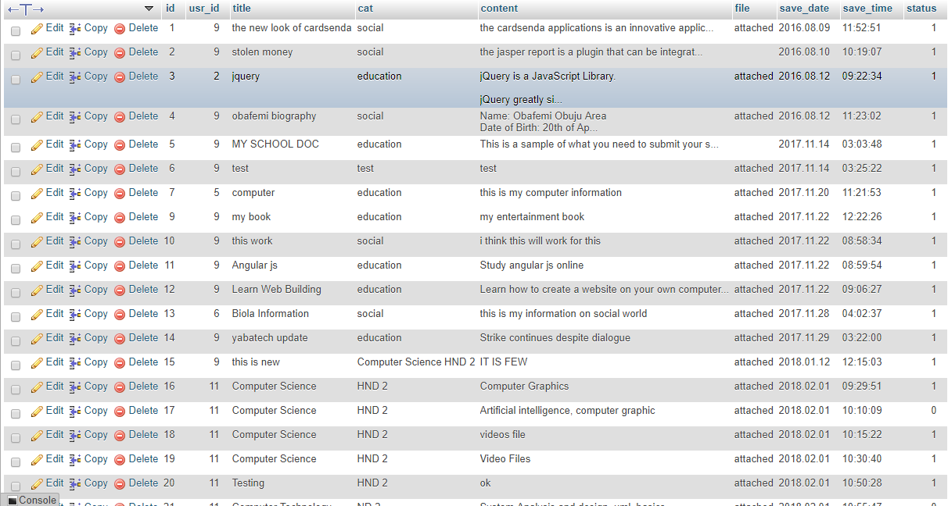 Figure 4.4.1: Library capture information store in database.

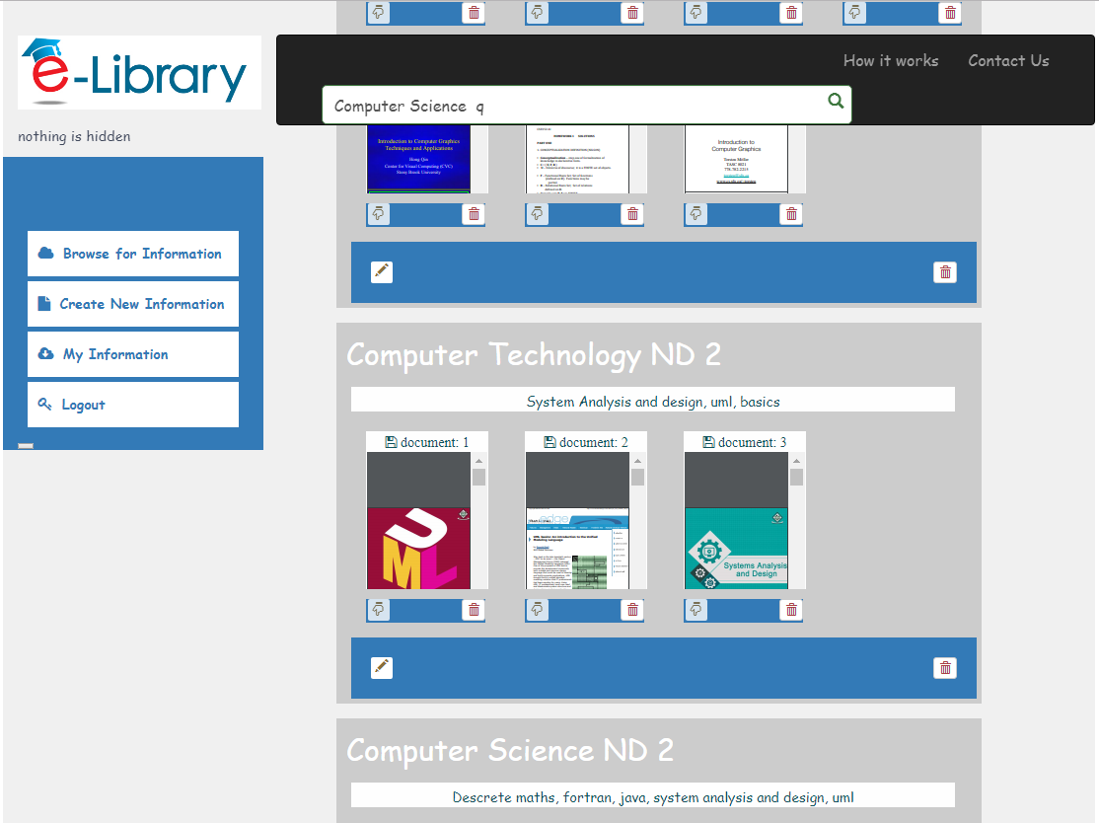

Figure 4.3.1: Library capture information store in database.

The E libray cloud information interface is the main core of the project, allowing user to access records, filter, download and manage (limited to the record owner). The search box filters the content of the page according to the user parameters. The hand pointing down is to download or preview the document depend on format. The information is represented in the database as the following; the electronic library table represented in the database stores information like:

**id** which is an integer format.

**usrid** which is an integer format for storing user id,

**content** it store large text value

**file** it signifies if document with or without an attachment

**savedate** which is a date format for storing date,

**savetime** which is a date format for storing time,

The page url will be vary from server to server but for the purpose of testing on local server the url is <http://localhost/elibraryGA/dashboard/document>, other description can be found on figure 4.3 above.

**4.4 Google Analytic Report Interface**

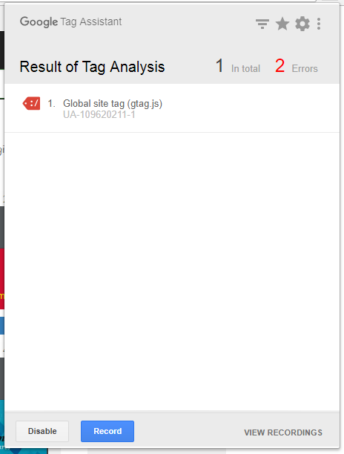

Figure 4.3.2: Google Analytic Recorder.

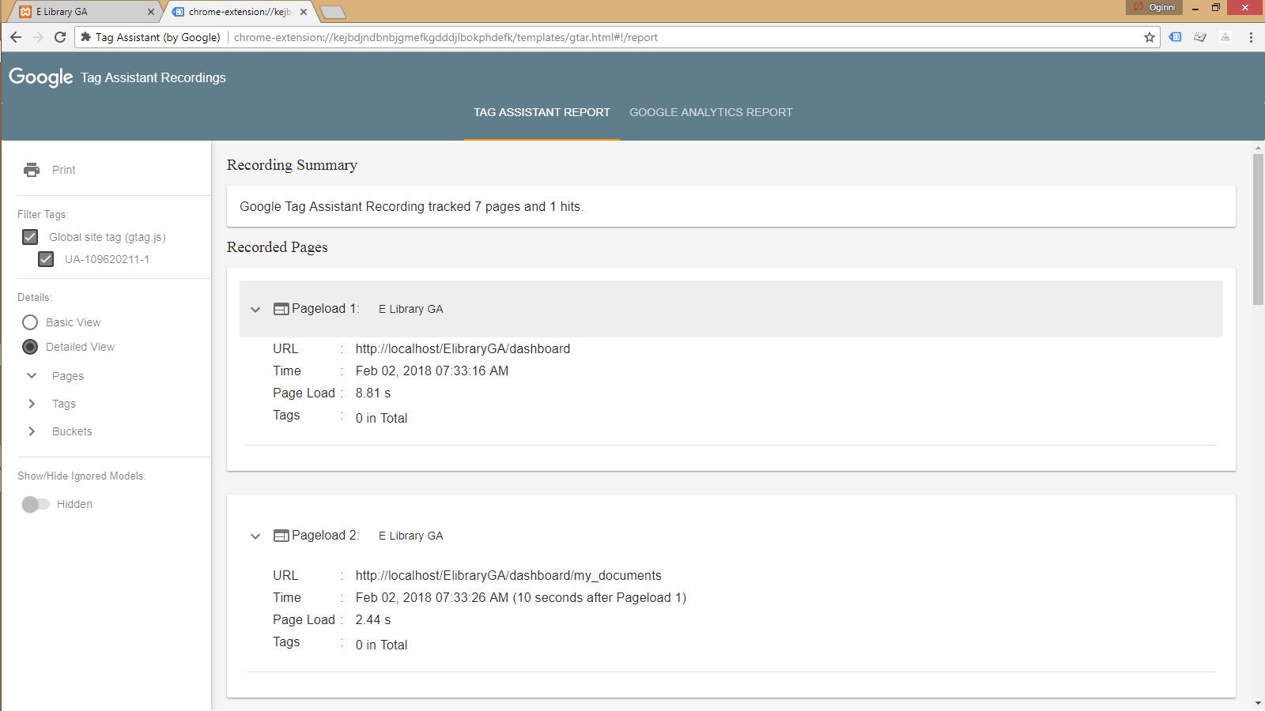

Figure 4.3.3: ElibraryGA Report from Google Analytic.

The Google Tag Assistant is a platform provides by the Google for monitoring and to debug effectiveness a website, the interface is a platform that gives details about each visited page by each visitor and user. The report of Google Analytic includes: Time of visitation, Error report on visitation, successful and unsuccessful dealing, total estimate time spend by user on the platform, overall time it takes to visit a particular page. Other description can be found on figure 4.3 above.

**References**

Bala Haruna, K. Kiran, Muzammil Tahira, (2017). "Modelling web-based library service quality and user loyalty in the context of a developing country", *The Electronic Library, Vol. 35 Issue: 3, pp.507-519, https://doi.org/10.1108/EL-10-2015-0211*

Barba, Ian, Ryan Cassidy, Esther De Leon, and B. Justin Williams. (2013). “Web Analytics Reveal User Behavior: *TTU Libraries’ Experience with Google Analytics.” Journal of Web Librarianship 7 (4): 389-400. doi: 10.1080/19322909.2013.82899*

Clifton, B. (2012). Advanced web metrics with Google Analytics. John Wiley & Sons.

Chua, A. Y. K., & Goh, D. H. (2010). A study of Web 2.0 applications in library websites. *Library & Information Science Research, 32(3), 203–211.*

Ekere, Justina n. dr.; omekwu, charles obiora; and nwoha, chidinma m. (2016). "User’s perception of the facilities, resources and services of the MTN digital library at the university.

Ezeani, C. N. (2012). Using social media for dynamic library service delivery : *the Nigeria experience. Library Philosophy and Practice, (October), 814*.

Fadhil, A., & Ali Al-Juboori, M. (2014). Design and Implementation of an E-Library Search System. *International Journal of Innovation and Applied Studies ISSN, 7(4), 2028–9324.*

Fagan, Jody Condit. (2014). “The Suitability of Web Analytics Key Performance Indicators in the Academic Library Environment.” *The Journal of Academic Librarianship 40 (1)*: 25-34. doi:10.1016/j.acalib.2013.06.005.

Hess, M. Ryan. (2012). "Web Analytics: Using Evidence for Improvement - Über Analytics: Customizing Google Analytics to Track Multiple Library Platforms.” *Paper presented at the annual Internet Librarian conference, Monterey, California, Oct. 2012*.

Jeong, H. (2011). An investigation of user perceptions and behavioral intentions towards the e-library. *Library Collections, Acquisitions, and Technical Services, 35(2), 45–60.*

Kanndppanavar, B. U., Rajanikanta, S. T., & Tandur, S. K. (2010). Importance of digitization of library materials. SRELS J Inf Manage, 47(1), 61–70.

Kehinde, A. (2017). Digital Libraries and the Role of Digital Librarians.*Handbook of Research on Managing Intellectual Property in Digital Libraries, 98.*

Khan, A., Khan, A., Qutab, S., & Qutab, S. (2016). Understanding research students’ behavioural intention in the adoption of digital libraries: *A Pakistani perspective. Library Review, 65(4/5), 295-319.*

Kim, Y.-M. (2011). Users’ perceptions of university library websites*: A unifying view. Library & Information Science Research, 33(1), 63–72.*

Thaker, K. (2017). Digital Library and User’s experience : *A Literature Review, 2(1), 1–8.*

Thillar, V. B. (2016). DIGITAL / E LIBRARY RESOURCE Keyword, 2(12), 20–23.

Rao, Y M V Naga Raja Rao (2013), “Library professionals – changing environment “eLibrary Science Research Journal, Vol .1, No. 8.

Xianjin Zha Jinchao Zhang Yalan Yan Wentao Wang(2015)," Comparing flow experience in using digital libraries Web and mobile context ", *Library Hi Tech, Vol. 33 Iss 1 pp. 41 – 53*.